PARISH COUNCIL MTG: Mells June 2024

Number of Crimes by Offence Type:

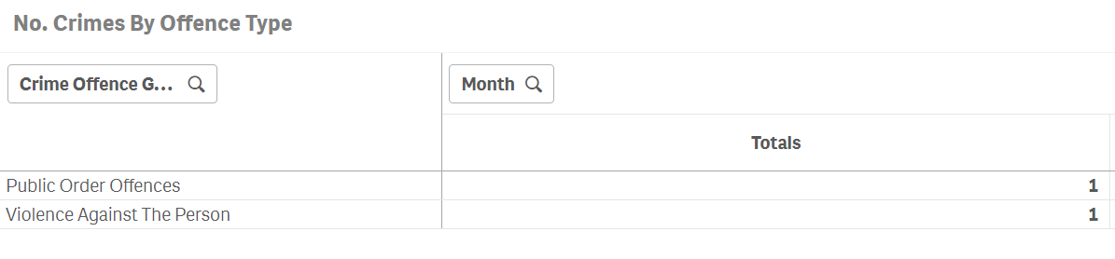

Number of Crimes Trend:

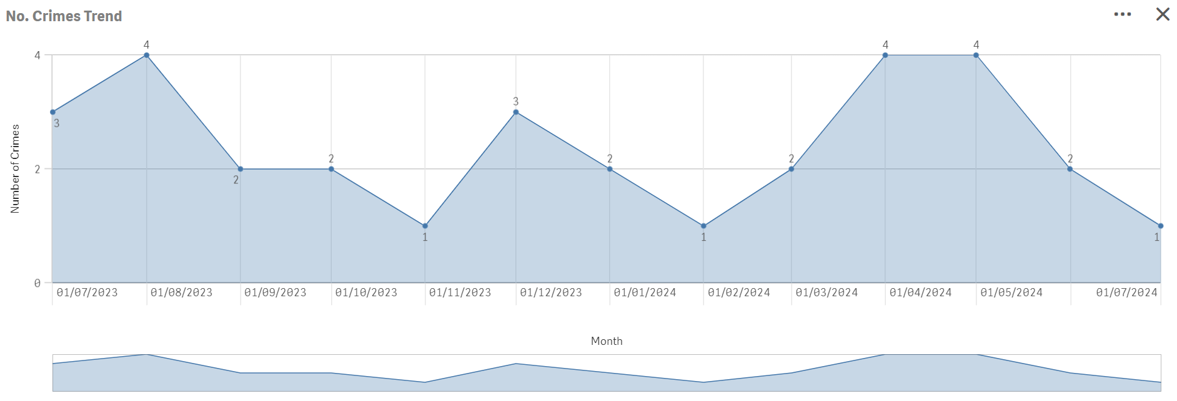

CURRENT PACT PRIORITIES:

Provide a visible Police presence in Mells

FUTURE PACT PRIORITIES:

Regular foot patrols are ongoing and productive community engagement.
Please remember to report Anti-Social-Behaviour and drug related incidents to 101 or 999, respectively.

OVERALL CRIME TRENDS

None of significant note

